Exp.No-4:

4. Perform basic Image Handling and processing operations on the image
• Read an image in python and Dilate an Image using Dilate function.

Aim:
To perform image dilation using OpenCV.

Procedure:
- Start the program.
- Import OpenCV and NumPy.
- Read the input image.
- Create a kernel matrix.
- Apply the dilation operation.
- Display the original and dilated images.
- Save the dilated image.
- Stop the program.
Program:
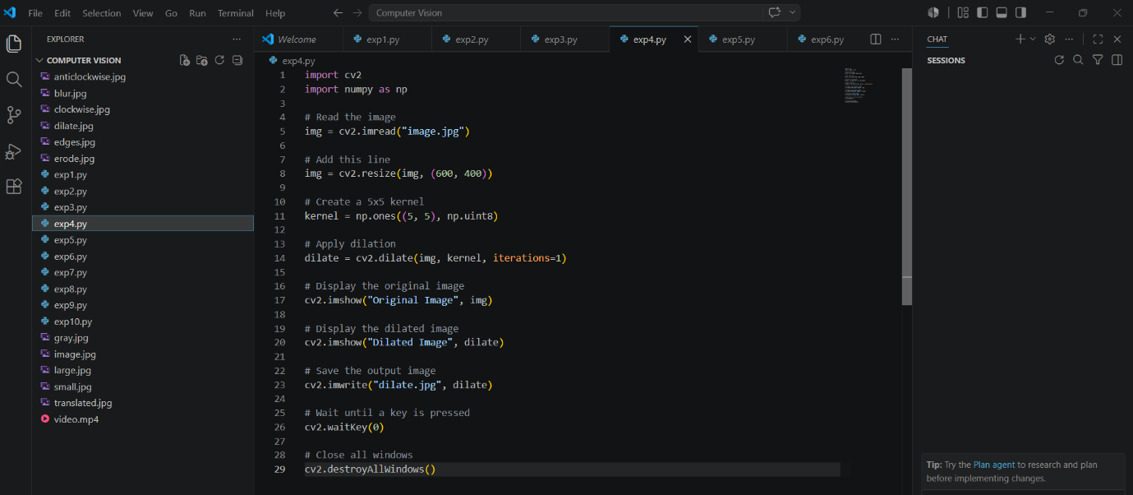

Input:

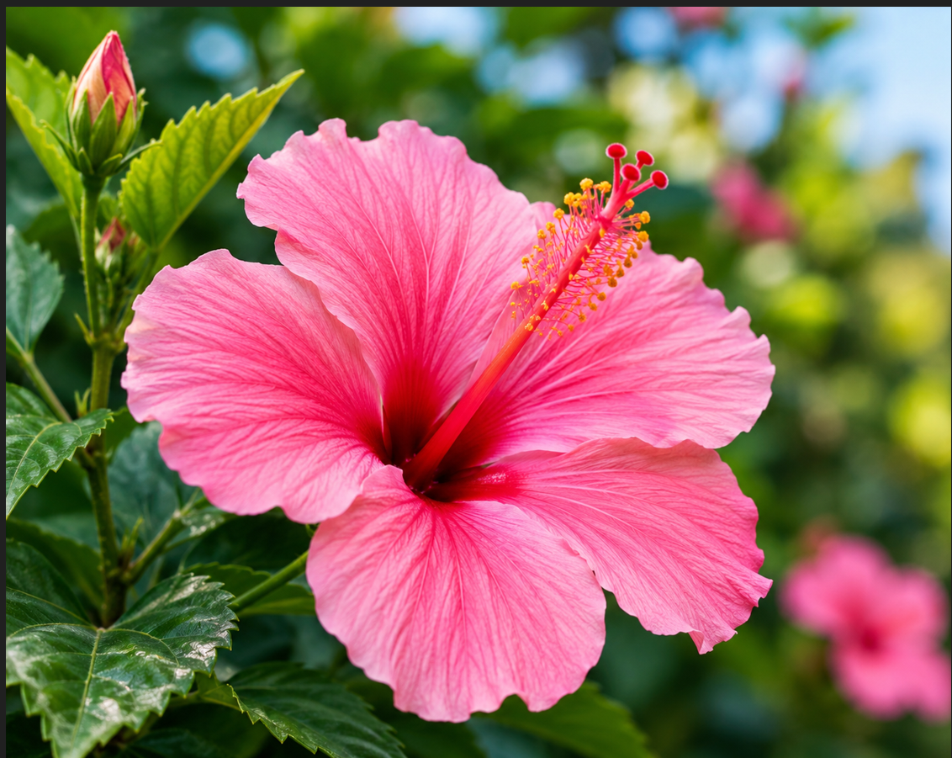

Output:
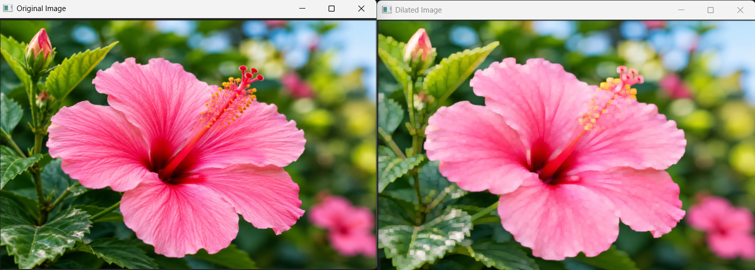

Result:
The image was successfully dilated, and the object boundaries became thicker.

